Project Design Phase-II
Data Flow Diagram & User Stories
Date | 02 October 2026
Project Name | Automated Network Request Management in ServiceNow
Maximum Marks | 4 Marks

Data Flow Diagrams:
The DFD represents how network request information moves through the ServiceNow solution: requester inputs enter through the Service Catalog, catalog variables are retrieved and mapped, Flow Designer creates the operational record, approval is requested and evaluated, the record is updated, notifications are sent, and the final request outcome is made available for fulfilment and tracking.
DFD Level 0 - Context Diagram
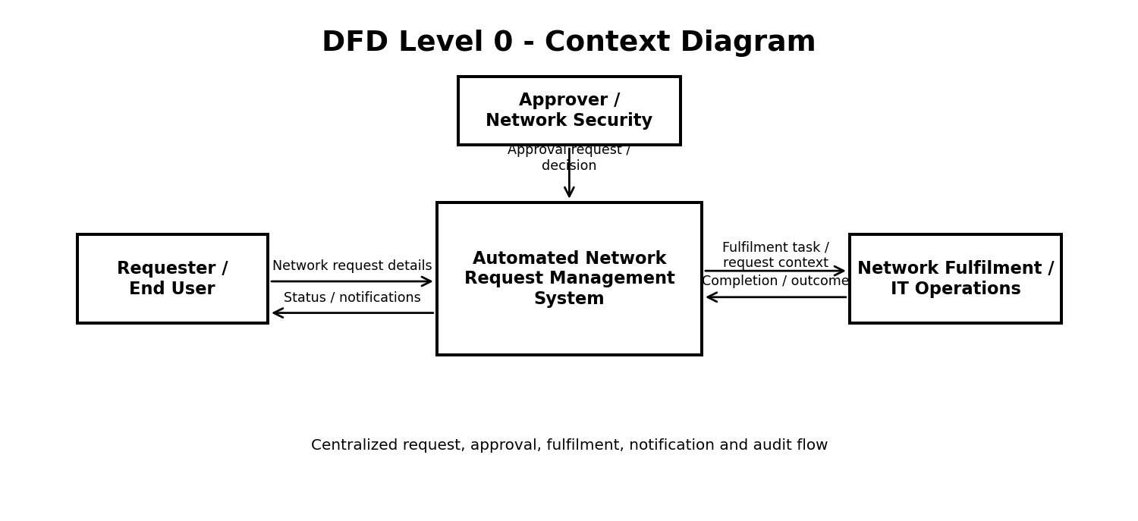
Level 0 treats the Automated Network Request Management System as one process. The requester supplies network-request details and receives status/notification outputs. Approvers or network-security personnel provide approval decisions, while the fulfilment/IT operations side receives the approved request context and returns the operational outcome.

DFD Level 1 - Detailed Data Flow
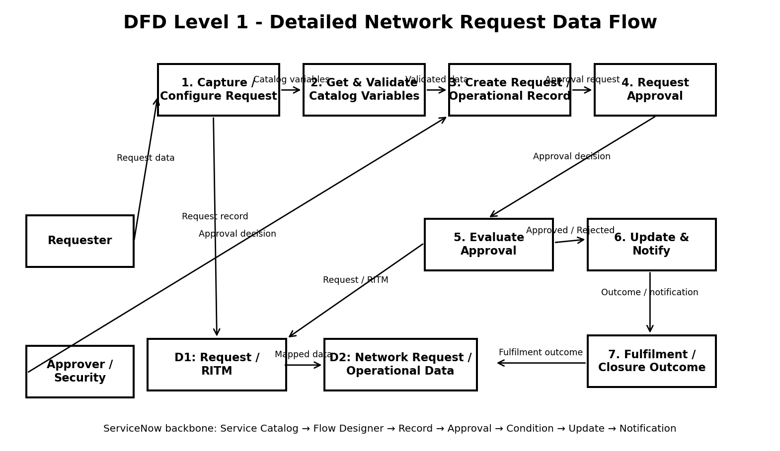
Level 1 Process Description
No. | Process | Data Flow / Function
1 | Capture / Configure Request | Collect network-request information through the Service Catalog and provide the submitted Requested Item Record to the flow.
2 | Get & Validate Catalog Variables | Retrieve the selected variables from the Network Request catalog template and make them available to downstream actions.
3 | Create Request / Operational Record | Create the configured operational record and map catalog values into its fields; initialize Approval Status as Requested.
4 | Request Approval | Send the created record into the configured approval action and obtain an approval decision.
5 | Evaluate Approval | Check the approval output and branch the flow according to whether the request is Approved or follows the Else path.
6 | Update & Notify | Update the operational record with the decision and send the corresponding lifecycle notification.
7 | Fulfilment / Closure Outcome | Pass the approved/rejected outcome into the operational lifecycle for fulfilment, tracking and closure.
Data Stores
• D1 - Request / RITM: Maintains the ServiceNow request and request-item context created when the requester submits the catalog item.
• D2 - Network Request / Operational Data: Represents the structured record populated by the flow from the submitted catalog variables. The supplied implementation screenshots currently show the visible table label 'Database Tables'; this terminology is retained as implementation evidence rather than silently changing it.
User Stories
The user stories below translate the implemented and planned functional requirements into user-centered tasks. Priority and release values are organized around the project implementation roadmap and distinguish current workflow capabilities from future enhancements.
User Type | Functional Requirement  (Epic) | User Story  No. | User Story / Task | Acceptance Criteria | Priority | Release
Requester | Network Request Submission | USN-1 | As a requester, I can open the Network Request catalog item and enter my required request information. | The catalog item opens and the required request variables can be entered successfully. | High | Phase 1
Requester | Catalog Variable Capture | USN-2 | As a requester, I can submit structured network-request data through the ServiceNow portal. | The Requested Item Record is created and the configured flow receives the submission context. | High | Phase 1
System | Variable Retrieval | USN-3 | As the system, I can retrieve the selected catalog variables from the Network Request item. | The configured variables are available as outputs for downstream flow actions. | High | Phase 2
System | Operational Record Creation | USN-4 | As the system, I can create an operational record using the submitted request values. | Mapped fields are populated correctly and Approval Status starts as Requested. | High | Phase 2
Approver | Request Approval | USN-5 | As an approver, I can review the network request and provide an approval decision. | The configured approver receives the request and an approval outcome is recorded. | High | Phase 2
System | Approval Routing | USN-6 | As the system, I can evaluate the approval result and follow the correct workflow branch. | Approved requests follow the Approved branch; other outcomes follow the Else path. | High | Phase 2
Requester | Request Notification | USN-7 | As a requester, I receive a notification when my request has been created. | A request-created email is generated after the operational record is created. | High | Phase 2
Requester | Resolution Notification | USN-8 | As a requester, I receive a notification when my approved request reaches the configured resolved stage. | The approved path updates the record and sends the configured resolved notification. | High | Phase 3
Network / IT Operations | Operational Record | USN-9 | As an operations user, I can access structured network-request records for fulfilment and tracking. | Mapped request information is stored in the configured operational record. | High | Phase 3
IT Administrator | Workflow Monitoring | USN-10 | As an administrator, I can inspect Flow Designer execution details when a request fails. | Execution details identify the failed action, condition path, input or output involved. | High | Phase 4
Administrator | Access Control | USN-11 | As an administrator, I can configure roles and ACLs to control access to network-request records. | Unauthorized users cannot access protected operational data beyond their permitted role. | High | Phase 4
Administrator | Maintainability | USN-12 | As an administrator, I can maintain the workflow primarily through Flow Designer and ServiceNow configuration. | Core workflow logic can be understood and modified without unnecessary custom server-side code. | Medium | Phase 4
Requester | Status Tracking | USN-13 | As a requester, I can understand the current status of my submitted network request. | The request status is available through the configured ServiceNow request experience. | Medium | Future
Network / IT Operations | Fulfilment Handoff | USN-14 | As a fulfilment user, I can receive the approved request context needed to perform the network operation. | Approved request information is available to the responsible fulfilment process or task. | Medium | Future
Acceptance Focus
The critical acceptance path is: requester enters valid network-request information → request is submitted through the Service Catalog → catalog variables are retrieved → the operational record is created → approval is requested → the approval result is evaluated → the record is updated → the appropriate notification is sent → the resulting request is available for fulfilment and tracking. Debugging of variable mappings, record creation, approval routing, condition logic and notification triggers is therefore directly linked to the high-priority user stories.

